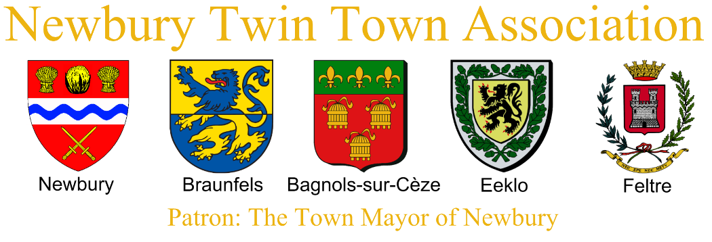
Newbury Twin Town Association Reunion – Easter 2018
Information for Helpers
Dear Twin Town Helpers,
Thank you very much for your offer of help during our Twin Town Easter Weekend. The event could not happen without your assistance and support.
The programme is attached for information and further details are below but please contact me if you have any questions.
The organising committee members (Zita, Gillian, June and myself) will be at every event to provide further guidance but are also hosting so help from non-hosting members is very valuable.
Name badges are available for all the helpers and the visitors and can be collected from June at the first event that you attend.
Kind regards,
Rachel
01635 820379
07919 555043

Thursday 29th March
Late Afternoon/Early Evening - Serving drinks and welcoming visitors when they arrive at Newbury Town Hall. Distributing Welcome Packs.
Helpers - Graham Salter, Mike Braide, Janet Palmer
Times – 5:30 to 9:30 approx. Gillian and I will be there for the whole time and will contact you on the day if arrival times change. Please do not feel that you have to be there for the whole duration if you have other commitments.
Braunfels - Arrive approximately 6pm.
Carcaixent - Arrive approximately 8pm.
Kiskunfelegyhaza - Arrive approximately 9pm.
Eeklo - Time to be confirmed. Likely to be early evening.
Feltre and Bagnols visitors will arrive by train (time TBC) and will be collected by their hosts from Newbury Railway Station.
Friday 30th March
8:30am onwards – Arrive at The Phoenix Resource Centre, 212 Newtown Road, Newbury RG14 7EB.
Set up tables, chairs, display pictures being produced by children from St Nicolas School, serve drinks during break, layout food for lunch, clear up after lunch.
Helpers – Barbara Cogswell, Mavis Greenhalgh, Sue Prime, Sue Simpson, Graham Salter, Mike Braide, Janet Palmer.
Coffee Break – 11:00 to 11:15 approx. Drinks to be served in downstairs café area. Urns available. Disposable cups and plastic beakers.
Lunch Break – 12:15 to 13:00 approx. Lunch to be served in upstairs large room. Finger buffet. Sandwich trays to arrive at 11:00. Other food to be displayed on platters. (quiche, sausage rolls, sausages, scotch eggs, tomatoes, crisps, fruit, cakes etc.).
Notes
- Plates are reusable and can be bagged and returned unwashed.
- Rubbish should be bagged and removed
- Left over cakes, crisps and drinks should be taken by any helpers with transport and brought to St Georges Hall on Saturday evening.
- Left over fruit to be returned to Rachel.
- Left over perishable food can be bagged and taken home by helpers if required.
- The lunch room will be used for 2 of the discussion groups in the afternoon (at 13:00 approx) so tables/chairs should be arranged for the groups. Group sizes of 14 and 10 people plus helpers
Presentation and Discussion Sessions
Leaders and Assistants
Braunfels (14 people) – Mary Rye + Jenny Blakeley (morning only) + Chris Harper + Karen Barraclough.
Bagnols-sur-Cèze (10 people) – Marian Hatfull + David Hatfull
Carcaixent (13 people) – Graham Salter + Jim Johnston
Kiskunfélegyháza (4 people) – Zita Lang
Newbury (unknown size) – Gillian Durrant + Rachel Haslam
Eeklo (6 people) – Ian Haslam + Moira Harkness
Feltre (6 people) – Abby Watson + Isla Simpson

Location of Discussion Groups
Braunfels – Lunch Room
Bagnols-sur-Cèze – Lunch Room
Carcaixent – Theatre
Kiskunfélegyháza – Theatre
Newbury – Theatre
Eeklo – Coffee Room
Feltre – Coffee Room

Clearing up
Chairs and Tables to be returned to original positions.
Pictures to be collected and returned to Zita.

Saturday 31st March
Museum
09:40 – Arrive at Newbury Museum. See additional information distributed by June.
Town Hall
10:15 – Set up Drinks, Projector etc at Town Hall. Helpers – Gillian, Rachel and Janet Palmer
11:00 – Take visitors from Museum to Newbury Town Hall for coffee and a short presentation on The History of Migration to West Berkshire.
Braunfels – Mary Rye + Karen Barraclough + Chris Harper
Bagnols-sur-Cèze – Marian Hatfull + David Hatfull
Carcaixent – Graham Salter + Jim Johnston
Eeklo – Kim Whittaker
Feltre – Isla Simpson + Moira Harkness
Kiskunfélegyháza – Zita Lang
St George’s Hall
17:00 – Arrive at St George’s Hall, Wash Common. Please bring a contribution of typical ‘British’ food (sweet or savoury) for the buffet. Please bring spare platters, serving spoons, salad servers if you have them.
Set up tables and chairs. Table cloths (banqueting roll), place settings, flower vases, wine and water on each table.
Food tables – Sections for each country will be identified by a flag. Vegetarian and Gluten free options to be identified. Puddings to be kept in kitchen and moved to hall when main course finished.
Plates – Use plates at St George’s plus extras loaned by Rachel.
Wine glasses – Use glasses at St George’s plus extras loaned by Rachel.
Cutlery – Use cutlery at St George’s plus extras loaned by Elizabeth.
All crockery, cutlery and glasses to be washed after use.
Please keep glasses, plates and cutlery on separate tables if possible so that they can be returned to the correct place.
Decorate hall with flags, banners etc.
Greet visitors and hosts when they arrive from 19:00 and place food contributions on buffet table.
Clear up at the end of the evening, dispose of rubbish, tables and chairs away, sweep floors etc.
Helpers – Kim Whittaker, Mavis Greenhalgh, Sue Prime, Graham Salter, Sue Simpson, Janet Palmer, Barbara Cogswell, Moira Harkness, Mike Braide, David Hatfull.
Sunday 1st April
Sunday Walk
15:00 (approx.) – Depart Donnington Grove Hotel for circular walk to Donnington Castle
Helpers – Zita, Gillian, June, Rachel, Graham Salter + TBC
Kind regards,
Rachel Haslam 01635 820379 or 07919 555043

