Easter Egg Hunt from Donnington Grove Hotel to Donnington Castle
- Start from the car park at the back of the hotel. Don’t forget to collect 6 matching egg pictures between the hotel and the castle.
- With the hotel behind you, turn right and walk along the road through the car park.
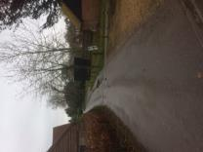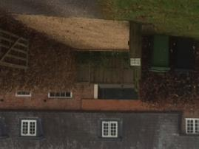
- At the end of the buildings, turn left uphill towards the castle.
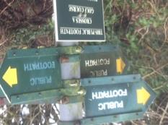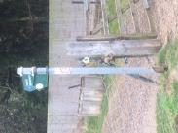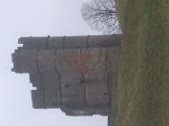
- Admire the view at the top and collect your chocolate egg! There will be a short talk about the history of the Castle.
- Retrace your steps from the Castle to the Castle Car Park.
- With the Castle on your right, follow the footpath from the car park through the woods.
- Emerging from the woods, turn left along the edge of the golf course.
- Cross the footbridge over the dual carriageway and follow the path down into Bagnor Village. Pass the Blackbird Pub on your right and follow the stream to the Watermill Theatre.
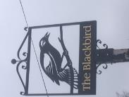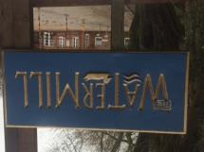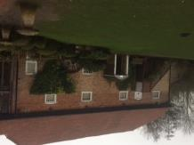
- Retrace your steps back through the village, up the track, across the footbridge and back to the golf course.
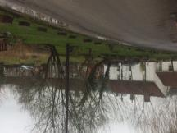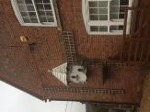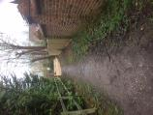
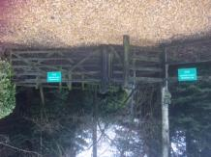
- Turn right following the ‘Public Footpath’ sign to head down the steps towards the road.
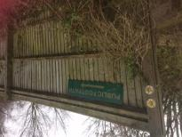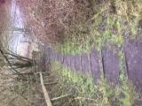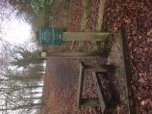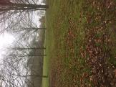
- Turn left and follow the path back to the golf course and the car park at rear of the hotel.
